**Project Design Phase-II**

**Technology Stack (Architecture & Stack)**

|  |  |
| --- | --- |
| Date | 15 October 2022 |
| Team ID | PNT2022TMID02682 |
| Project Name | Smart Solution for Railways |

**Technical Architecture:**

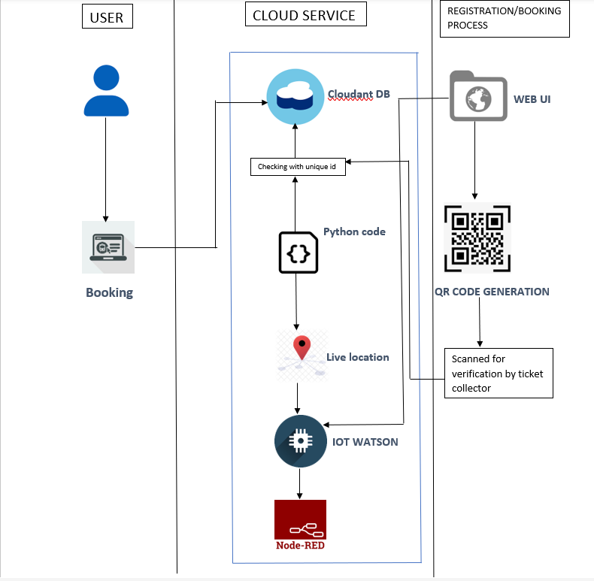

**Table-1 : Components & Technologies:**

|  |  |  |  |
| --- | --- | --- | --- |
| **S.No** | **Component** | **Description** | **Technology** |
| 1. | Web UI | User can login and book their ticket through the website based on the availability of the seats. | HTML, CSS, JavaScript |
| 2. | Cloud Services | Requirements filled by the passenger is stored in the cloud database. | Python |
| 3. | GPS Tracking | Live Location details shared through the code to share the location in the website | IBM Watson Service |
| 4. | External API-1 | Used for rail schedule, ticketing and travel documents generation, cancellation. | Sabre API |
| 5. | External API-2 | Used for combining carriers and ticket types, Multilanguage & currency support. | Trainline B2B API |
| 6. | Data Processing | Ticket is verified with the unique ID generated with the cloudland DB | Python, IBM cloud |

**Table-2: Application Characteristics:**

|  |  |  |  |
| --- | --- | --- | --- |
| **S.No** | **Characteristics** | **Description** | **Technology** |
| 1. | Open-Source Frameworks | CSS, Backend framework, | Python, IBM cloudant DB |
| 2. | Security Implementations | Data entered are encrypted, Continuous Location Tracking | Python, Cloud service |
| 3. | Scalable Architecture | The scanner and the codes written are highly scalable where any implementation can be done anytime needed | Python |
| 4. | Availability | Any time available system. The ticket can be verified by the ticket collector from anywhere. | IBM Load Balancer |
| 5. | Performance | Though the details are get stored in the cloud the system crash will not affect the data. The data can be retrieved from anywhere with a scanner. And the GPS states the exact location of the train. | Distributed Services, GPS Tracker |